# Task:1

Lab 1: Setting Up the Java Development Environment:

# Installation Report:

**JDK and IntelliJ IDEA:**

This report documents the installation process for the Java Development Kit (JDK) and the Integrated Development Environment (IDE) IntelliJ IDEA.

# Software versions used:

* JDK: [ version ( 19.0.2)]
* Location of java in lp: C:\Program Files\Java\jdk-17\bin
* IntelliJ IDEA: [ downloaded IntelliJ IDEA version ( Community 2024.1)]
* Location: C:\Program Files\JetBrains\IntelliJ IDEA Community Edition 2024.1\bin

# Operating System:

Operating system (Windows 10)]

# JDK Installation:

1. **Download the JDK:**

Oracle website (<https://www.oracle.com/java/technologies/downloads/>) and download JDK installer for operating system

# Run the installer:

Downloaded installer file.

Follow the on-screen instructions to complete the installation.

# Windows:

Choose an installation directory. The default location is usually C:\Program Files\JetBrains\IntelliJ IDEA <version>

# Configure IntelliJ IDEA (Optional):

During installation, you can choose to import settings from a previous IntelliJ IDEA installation or configure them manually.eg

1. Customize colors and font size.
2. Choose or customize shortcuts.
3. Extend functionality as needed.
4. **:** Ensure consistent formatting.
5. Integrate Git or others.
6. Specify JDK and settings.
7. Manage modules and dependencies.
8. Use predefined or create custom ones.
9. Configure debugging options.
10. Define custom actions or shortcuts.

**Shortcuts:**

**Debugger:**

**Templates:**

**Project Structure:**

**Build Configurations:**

**Version Control:**

**Code Style**

**Plugins:**

**Keymap:**

**Appearance and Theme:**

1. The IntelliJ IDEA Welcome screen should be displayed.

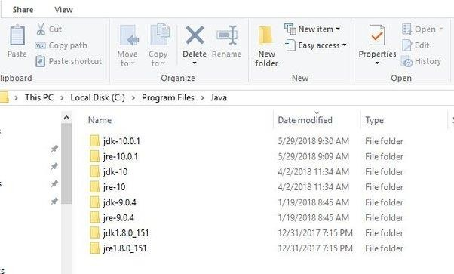

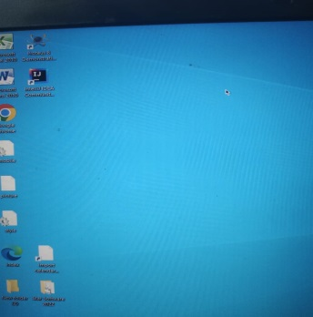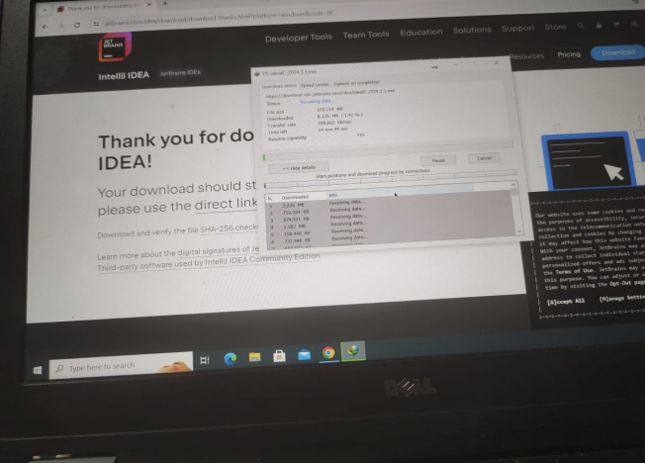

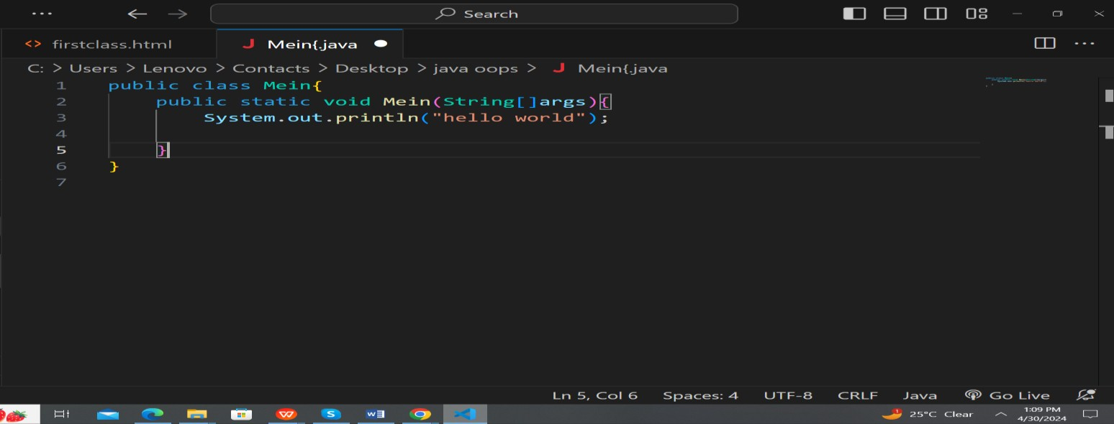

# Task: 2

## Public class HelloWorld {

Public static void main (String [] ergs) { System.out.println ("Hello, World!");

## }

**}**

**1. Class Declaration**:

**public class HelloWorld {... }**

* In Java, every program consists of at least one class, and the class name must match the file name. Here, we declare a class named .

**: public static void main (String []**

**args) {...}**

* In Java, the method serves as the entry point of the program. It must be declared exactly as shown here for the program to run.

•

•

The The class.

keyword indicates that the method can be accessed from anywhere.

keyword means that the method belongs to the class itself, not to instances of the

* specifies that the method does not return any value.
* **String [] args** declares a parameter named **args**, which is an array of strings. This allows the program to accept command-line arguments.

:

•

is an object of the standard output stream.

is a method of the output stream.

class that represents the

•

class used to print a line of text to the

•

is the string argument passed to the message that will be printed to the console.

method. This is the

**java.io.PrintStream**

**System. Out**

**("Hello, World!");**

**System.out.println**

**3. System.out.println () Method**

**main**

**2. Main Method**

**Void**

**static**

**public**

**HelloWorld**

**println ()**

**"Hello, World!"**

**Print Stream**

**println()**

|  |  |  |  |
| --- | --- | --- | --- |
| In summary, the combination of class declaration, main method, and the | | **System.out.println** |  |
| **()** | method is essential for creating a basic Java program that outputs "Hello, World!" to the sss | | |

## Roll No: 23BS (AI) 12

**Name: Ghanwa**

**Subject: OOP**